📄 OrderKraft Architecture Document

1. Overview
System Name: OrderKraft
Type: Enterprise Resource Planning (ERP) – Supply Chain & Production Management
Purpose: To streamline operations across procurement, inventory, production, and supplier management.

2. Objectives
- Manage procurement and purchase orders efficiently.
- Track inventory levels with alerts.
- Schedule and monitor production tasks.
- Handle payments, invoices, and supplier performance.
- Enable role-based access for different stakeholders (e.g., Procurement Officer, Inventory Manager).

3. System Architecture
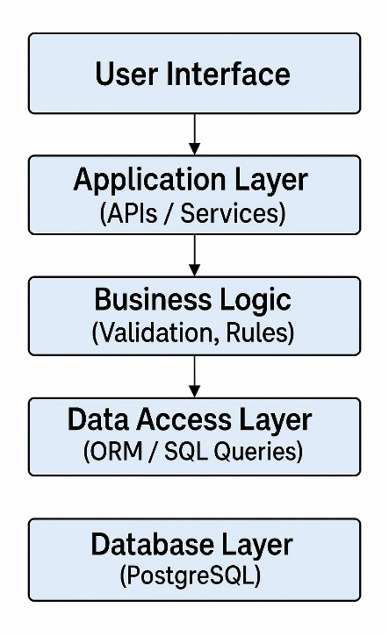
4. Modules
4.1. User Management
- Roles: Inventory Manager, Procurement Officer, Production Manager.
- Tables: user, roles
4.2. Order Management
- Features: Create/View orders, add order items, view order history.
- Tables: order, order_item, payment, invoice
4.3. Inventory Management
- Features: Track stock, trigger alerts, categorize items.
- Tables: inventory, inventory_alert, product, category
4.4. Production Management
- Features: Schedule production, assign tasks, manage units.
- Tables: production_schedule, production_task, production_unit
4.5. Supplier Management
- Features: Manage supplier info, contracts, performance.
- Tables: supplier, contract, supplier_performance, raw_material

5. Data Relationships (ER Summary)
- A user is assigned a role.
- An order is placed by a procurement officer (user).
- An order has multiple order_items.
- A payment and invoice are linked to an order.
- inventory is tracked per product, managed by an inventory manager.
- production_schedule is created by a production manager, includes production_tasks, and uses production_units.
- suppliers provide raw_materials and are evaluated through supplier_performance.
6. Technologies (Suggested Stack)
Layer | Technology
Frontend | React / Angular
Backend | Node.js / Java / Django
Database | PostgreSQL / MySQL
ORM | Sequelize / Hibernate / Django ORM
API Protocol | REST / GraphQL
Hosting | AWS / Azure / GCP
Authentication | JWT / OAuth2

7. Security Considerations
- Role-Based Access Control (RBAC) via roles.
- Input validation in APIs.
- Secure transmission (HTTPS).
- Database encryption for sensitive data (e.g., payments).

8. Scalability
- Horizontal scaling of frontend and backend services.
- Database optimization using indexing and caching.
- Asynchronous job queues for tasks like email, alerts.

9. Deployment Pipeline
1. Code pushed to Git
2. CI/CD triggered (GitHub Actions / Jenkins)
3. Unit + Integration Tests run
4. Docker container builds
5. Deployment to staging / production (Kubernetes / ECS)

10. Future Enhancements
- Integration with third-party payment gateways.
- Real-time dashboard with KPIs.
- AI-powered inventory forecasting.
- Mobile app interface.

